Please complete this form with as much information as possible & return to me via email clare@muddymutleys.com.

Date:
Your Details
Full name:
Home address:

Telephone number: Email address:

Please give ages of any dependants living at the address, or visiting regularly:
Occupation/s of adults:

Where did you hear about me/Muddy Mutleys:

Pets Details:

Name:
Gender: M/F
Age:
Breed:
Size/Weight:
Age at acquisition:
How long have you owned:
Age when neutered/spayed: Why?:
Where was your dog obtained from:
What is your dog’s previous history (rescue / had different guardians?)

Please outline giving as much detail as possible, the behavioural problems you are experiencing.

Please give as much information as you can: (age of weaning, litter size, parent’s characters, raised inside or outside, environment, hand-reared).

Were there any problems when your dog first entered the home?

Describe your dog when you first got him/her. E.g. energetic, hyper, chilled, worried, happy, playful, scared etc.

Has your dog’s character changed since you first got him or her? If so in what way?

When did you first notice this? Does this tie into a visit with the vet an injury or any medication, a bereavement, change of routine, house move etc?

Do you have any other dogs in the home? If so, please detail with name, type and age.

Are there any other animals in the home?

What is their relationship like?

Has your dog lived with any other animals in the past that you no longer have? Y/N
If so please give details:

How long is your dog left alone at home on an average day?

How does your dog behave with new visitors?

How long ago since you received a visitor that your dog doesn’t know?

Medical: You will be contacted before any request is made for records. For some behavioural concerns, vet records are important to build a complete picture.
Veterinary practice: Vets telephone number: Permission to Obtain Records: Y / N

Does your dog receive vaccinations and when were they last vaccinated? If Titre Tested please note last test date and result.

Does your dog have any allergies that you are aware of: foods/grass/pollen?

Please detail each time your dog has visited the vet including approximate dates and the reason for the visit.

Is your dog currently undergoing any treatment with your vet. Y/N
If yes, please give details:

If they are no longer on medication, please state what it was and when they completed the course of treatment.

Was your dog undergoing any treatment when the behaviour or a change in behaviour or character first appeared: Y/N
If yes, please give details:

Has your dog had a full clinical check since the behaviour started: Y/N
If yes, what was the outcome?

Did the vet take blood tests? N/Y
If yes, what were the results?

What type of flooring do you have in your home?

If your dog is insured, please state what type of insurance and which insurance provider:

General Care
Who walks, feeds, trains and plays with the dog?
Do you groom your dog? Y/N
If yes, how often?

Do they like it?

Do you use a cage / crate in your home? Y/N
Where does your dog sleep at night?
If on your bed, do you invite up? Y/N
If asked will the dog get off the bed/furniture: Y/N
Does your dog ever wake up in the night? Y/N
If yes, then why?

Diet
What brand of food do you feed your dog? What are your dog’s favourite top 10 treats?

Has this changed? When?
At what times of day do you feed your dog?
Who feeds your dog?
Where is your dog fed?
How is your dog fed? Ie bowl/Kong/activity ball/hand etc:
Will your dog eat if you are not there? Y/N
Does he/she eat quickly? Y/N
Does your dog drink very often?
How would you say your dog’s toileting is? Describe if you can.. Yep.. I know!! Where does your dog like to go? Frequency? Quality? Colour?
Exercise
How often is your dog walked?
How long is each walk on average?
How often is your dog off lead?
What do you use to walk your dog? (Harness / Lead on collar)
Does your dog take part in any canine sport?
Does your dog prefer to play with other dogs or with family members?
If you play with your dog, who initiates the play?
What type of toys does your dog play with? What are your dog’s favourite top 10 toys?

Does your dog often mix and play with other dogs? If so, please give details:

Does your dog happily jump into and out of the car?
Previous Guidance:
Has/or is your dog seen/seeing another behaviourist or trainer about these or any other problems:
Y/N
If yes please give details:

Behaviourist/Trainers name:
Advice given:

What’s worked, what hasn’t worked so well?

Aggression:
Has your dog ever been aggressive or threatening towards people or dogs? Y/N
Person/Dog

Please indicate to what level this has been shown:

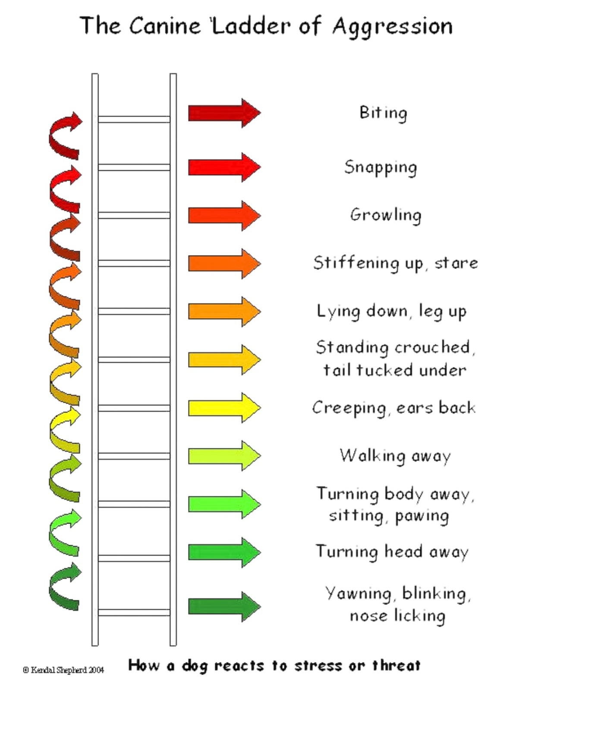
Has your dog ever bitten a person or a dog? Y/N
Person/Dog

If yes please give as much detail as you can about these occurrences including frequency, severity and consequences.

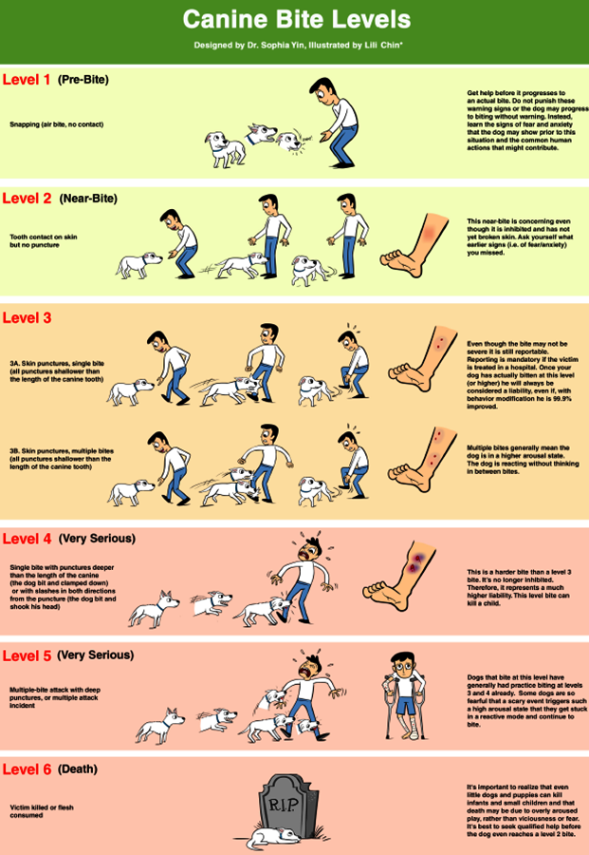
Training
Have you attended training classes with your dog: Y/N
If yes, at what age was your dog in classes?
Where were the classes?
What methods were used in the class?
How did your dog do?

How good do you think your dog is at learning?
What does your dog do best? Sit/down/paw/recall…. etc

Does your dog struggle to carry out any commands?

Does your dog obey certain members of the family more than others? Y/N
If so, who?

Is your dog corrected if he/she misbehaves? Y/N
If yes, how?

Personality
How would you describe your dog’s personality?
Is your dog frightened of anything? Y/N
If yes please give details:

If yes how does your dog react?

What areas of training /behaviour would you most like help with? Please prioritise these:
1.
2.
3.
4.
5.

Requirement:
What behaviour issue are you having with your dog? Eg. Aggression to dogs/aggression to people/doesn’t like being left/barking/manic behaviour etc.

What does this behaviour look like? Eg growling, barking, biting, pulling on the lead, crying, shaking, whimpering, being destructive etc?

Does it occur in conjunction with other behaviours or in isolation?

Are there any specific behaviours that occur directly before the problem behaviour, or behaviours that predict the problem behaviour?

How long does the behaviour last?

When did the animal start to show this behaviour?

How long has this been a problem?

When does the problem occur? Eg on sight of other people on walks/on sight of other dogs on walks/when people enter the house etc. Certain weather conditions, Pre walk, post walk? Certain locations? Time of day?

How do you react in these situations?

What have you tried to cure the problem and what has been the result?

Are there situations when under the conditions listed above, that the problem behaviour doesn’t occur or is less likely to occur?

Have you or your dog ever been prosecuted under control or welfare of an animal? If yes please give details

Please state any other information or problems that you feel are relevant to this case

What are your goals?

Does your dog have any of the following tendencies or behaviours?
Stealing food Often/sometimes/never
Eating excrement Often/sometimes/never
Sexual behaviour towards humans Often/sometimes/never
Sexual behaviour towards dogs Often/sometimes/never
Excessive fearfulness Often/sometimes/never
Excessive scratching or licking Often/sometimes/never
Object guarding Often/sometimes/never
Location guarding Often/sometimes/never
Barking or growling at strangers Often/sometimes/never
Biting strangers Often/sometimes/never
Growls at or bites family members Often/sometimes/never
Aggressive when petted Often/sometimes/never
Aggressive when brushed Often/sometimes/never
Aggressive when touched Often/sometimes/never
Aggressive when pushed/shoved Often/sometimes/never
Aggressive when picked up Often/sometimes/never
Aggressive when punished Often/sometimes/never
Aggressive when woken up/disturbed Often/sometimes/never
Aggressive when eating Often/sometimes/never
Urinates in the home Often/sometimes/never
Defecates in the home Often/sometimes/never
Destructive in the home Often/sometimes/never
Excessive barking/whining Often/sometimes/never

You recognise that the services offered are designed to provide science-led, force-free advice and suggested protocols to follow to aid in training and behavioural modification. The onus is on you, the client, to do the work needed and to follow the guidance given.

The behaviour of your dog and the liability attached to that behaviour is solely your responsibility and will always remain so.

Muddy Mutleys and Clare Grierson cannot sanction the unethical treatment of any dog in its care by way of client relationship. There is a strict force-free policy whilst working with me at Muddy Mutleys. It is expected to be adhered to at all times.
Please ensure that your dog has a well fitted harness. Clare will not be able to work with you should you be working with a lead on a collar, or any equipment that may cause harm or discomfort. If you are unsure, then please ask and we will supply you with information to help.

Cancellation of behaviour consultation, 121 appointments, classes or workshops:

Please note that while you are working with Clare please adhere to her guidance. If you are working with or taking advice from other trainers, please disclose this, but be aware that it may result in termination of your agreement with Clare. Clare may direct you to other professionals, specialists and or resources that meet with her ethical standards.
Clare will be happy to work in triage with other professionals such as dog walkers if this is disclosed and arranged up front but again, you will be expected to work under her instruction.

If you are unable to attend your class but decide to book a place on the course then unfortunately, we cannot waiver the fees for the lessons you miss.

In the unlikely event of the training session being cancelled by MMDTS a catch-up lesson will be given in return.

Non-refundable deposits will be taken as per the website on the booking of a behaviour consultation.

Full payment should be made 5 days prior to the consultation or else receipt of payment is needed before any support or reports of the session are sent out.

If you cancel your appointment a week before the consultation is supposed to happen you are obliged to pay a cancellation fee.

If you cancel your appointment 24 hours or less before the consultation is due to take place you are obliged to pay a cancellation fee.

Full payment should be made 5 days prior to the consultation or else receipt of payment is needed before any support or reports of the session are sent out.

If you cancel your appointment a week before the consultation is supposed to happen you are obliged to pay a cancellation fee.

If you cancel your appointment 24 hours or less before the consultation is due to take place you are obliged to pay a cancellation fee.

If you pay for consultations and you do not arrange for these within 2 months of booking, we are unable to refund, re-arrange or replace with other services for you.

If on a legal consult or behaviour consultation the recommendation is that the dog be euthanized
you are not eligible for a refund and full fee for the work and report required will be taken.

Signed (Owner) _______________________________

Date _______________________________

Thank You
Clare NL Grierson
07532 243153
www.muddymutleys.com;
yell.com/DogTrainers/Enfield

If it helps:

What are you doing? | What is the dog doing? | What is the result?

What would be the perfect dog in this situation……

What are you doing? | What could the dog be doing? | What could be the result?

